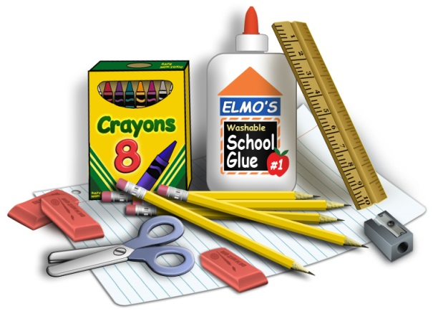

**6th Grade**

**Supply List**

To All Incoming 6th Grade Students,

In order to be prepared for Sixth Grade, you will need to bring the following supplies with you to the **first day of school**:

* 2 inch binder

**Items not allowed in 6th grade classrooms:**

CELL PHONES

BODY SPRAY/PERFUME

* Dividers
* Loose leaf paper (1 small pack)
* Three dozen pencils
* Black or blue pens
* Erasers
* Hand-held pencil sharpener
* Pencil case or bag
* Two different colored highlighters
* One hard-covered marble composition book
* Colored pencils (smallest pack is fine)
* Markers (smallest pack is fine)
* Tissues (two large boxes)
* Clorox Wipes (one)
* ***OPTIONAL:***  Headphones or earbuds

Enjoy the rest of your summer! We look forward to seeing you in September!

Sincerely,

The Sixth Grade Team

(Mrs. Reichert, Mr. Fox, Mr. Sabol)