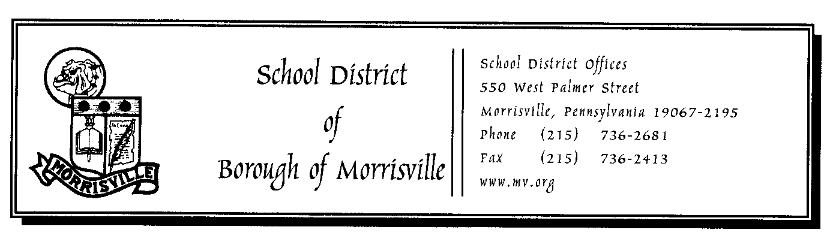

**Act 48 Approval Request Form**

**Name of Applicant**: Enter Name

**Course Work**

**Exact title and full description of course requested to take:**

Enter Text

**Date(s) of Course:** Click here to enter a date. **Course Hours to be Awarded** Enter #**:**

**Name and location of College, University or Organization Presenting:**

Enter Text.

**Professional Development** *(Please describe activity below)*

**Pennsylvania Department of Education approved in-service courses for credit** Courses approved for credit by the PDE, as initiated by a local area in-service Council (BCIU). Through such courses, educators can obtain 24 credits required for maintaining certification or to obtain a Master’s Equivalency certification.

**Professional Workshops and Conferences.** Participation in education-related meetings, seminars, workshops, etc.

**District In-Service Activities.** Courses, workshops, and seminars taught or conducted by administrators, members of the staff, or outside consultants to provide additional experiences and further the development of skills.

**Visitations to Other Schools.** Cooperative effort between the District and one or more districts in which Morrisville staff will visit and observe in the cooperating school(s) for the purpose of educational improvement and Professional Development. The opportunities for reciprocal visits are encouraged.

**Curriculum Development Work**. District sponsored individual and group work on educational programs. This would include, but not be limited to planned course development, creation of a new syllabus, including preparing instructional materials, as well as gathering resources prepared by others, integrated units, curriculum writing and curriculum enrichment.

**Peer Visitation**. Visits to educational activities with the approval of the teacher(s) involved and Superintendent of Schools and with notification to the appropriate supervisor/administrator.

**Structured Professional Interaction Time (articulation)**. Specific time allocations for subject area, grade level, department head and/or special area interaction. This allocation provides articulation within a department, grade, or school within the District.

**District/College, Business Workshops Seminars/Partnerships**. Participation in employment related seminars, workshops, or partnerships sponsored by District, local colleges or universities and business.

**Peer Coaching**. Voluntary observations and feedback between colleagues for purposes of improvement in instruction.

**Participation in Professional and Subject Area Associations.** Attendance and participation at professional meetings for purposes of professional enrichment and growth. Participation at meetings as “presenters,” as well as “participants,” is encouraged.

**Grant Proposal Development**. Preparations of grant requests seeking federal, state, local or private sector funds to plan and develop projects that will enhance the District’s educational program and be a direct benefit to students and/or staff. The Superintendent of Schools must approve all grant requests prior to submission of grant.

**Other Professionally Related Activities.** Other activities may be arranged, subject to the approval of the District Act 178 Committee and the Superintendent of Schools. The Superintendent of Schools must approve work on all grant requests prior to the use of professional days on the grant preparation.

**Details**

**Date of Professional Development:**Click here to enter a date. **Credit Hours Earned:** Enter Amount

**Location:** Enter School, Organization, etc.

**Please describe activity:**Enter Text

**Your Signature:** ______________________________________________________________

**Principal or Dean Signature (Recommendation):** ____________________________________

**Date received in Superintendent’s Office:** _________________________________________

**Superintendent’s Signature:** ____________________________________________________

*Once all signatures have been obtained, a signed copy will be given to the employee and a copy will be kept in the Superintendent’s office until proof of course completion has been provided.*

*Upon receipt of course completion, a copy will be placed in your Personnel file and a copy will be sent to Lynn Palumbo to be entered into PDE.* *If no certificate was awarded, please attach a written description of the course content.*

**Date Sent for Act 48 Credit Entry:** ___________________________